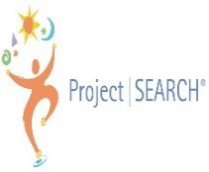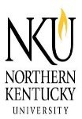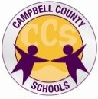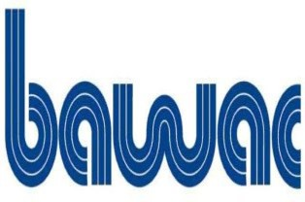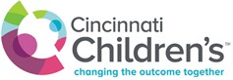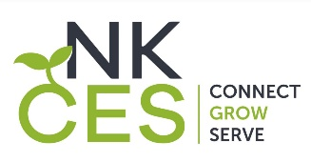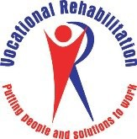

Norse Project SEARCH
What: Open House for 2023-2024 School Year
Date/Time: November 30, 2022, at 6:00p.m.
Location: NKU Campus Recreation Center, Multi- purpose Room 2, #283
Norse Project SEARCH Transition Program: is a one-year internship program for students with disabilities, in their last year of high school. It is targeted for students whose goal is competitive employment. The program takes place at NKU where total immersion in the workplace facilitates the teaching and learning process as well as the acquisition of employability and marketable work skills. Interns participate in 3 internships to explore a variety of career paths. The interns work with a team that includes their family, a special education teacher, community rehabilitation provider, and on-site internship supervisor to create an employment goal and support the intern during this important transition from school to work.

Example Internship Sites at NKU:
- Campus Rec Center
- Human Resources
- Facilities Management
- Food Service
- Child Development Center
A Few Student Benefits of the Project SEARCH Model:

- Participate in a variety of internships within Northern Kentucky University
- Acquire competitive, transferable, and marketable job skills
- Gain increased independence, confidence, and self esteem
- Obtain work based individualized coaching, instruction, and feedback
Are you interested in learning more?
Please join us Nov. 30th at 6:00 p.m. to hear more about this terrific program! Questions? Please email: lindsay.heiert@campbell.kyschools.us or call 859-572-7923

